

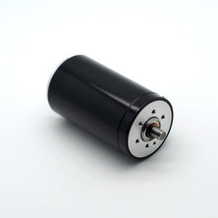

#### 40X70mm Coreless Brushed Series

**SPECIFICATIONS:**

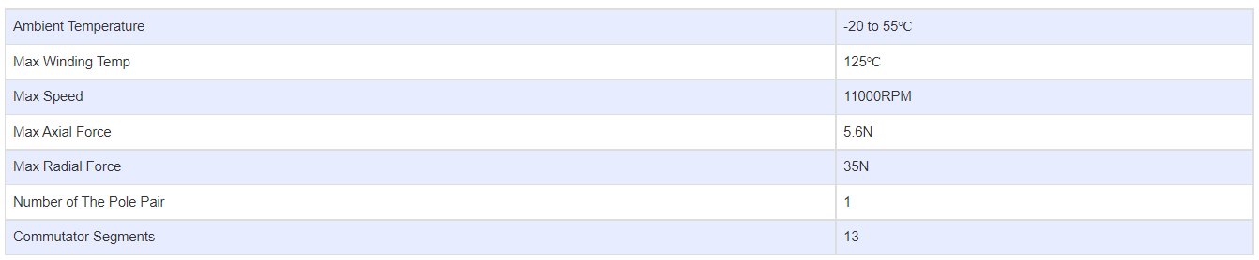

**SUBMODELS:**

*The following are common submodels for the LDO-CL4070 series.*

